May 2008 Derek McCrea Artists Newsletter

This month has probably been one of the most busy months ever for me for creativity and art.

First several of my works are now available on limited edition designer scarves through Designer Scarves by Marlena
http://www.designerscarvesbymarlena.com/

To begin the month I began with a new series of wildlife paintings. I also started using yupo paper for some abstract realism with parrots and butterflies

The works below are available at my gallery at http://www.derekmccrea.50megs.com

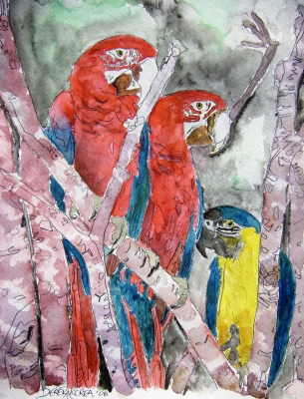

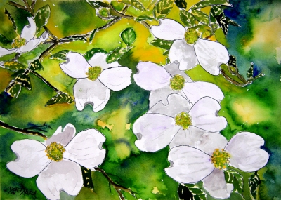

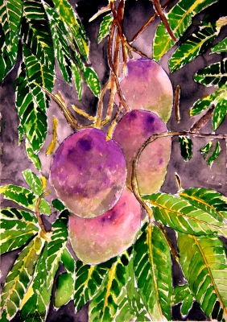

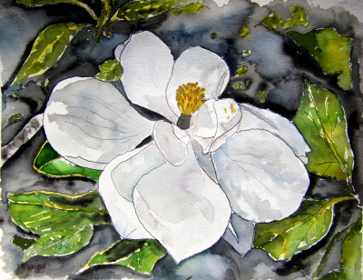

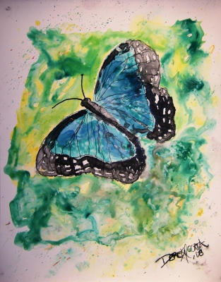

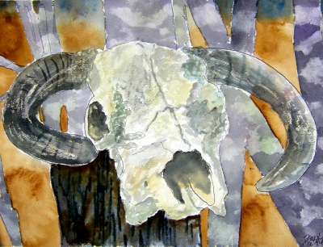

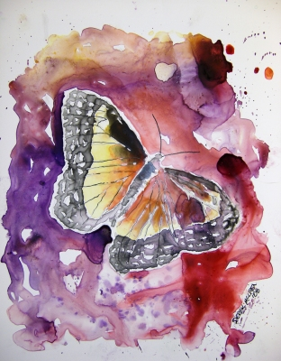

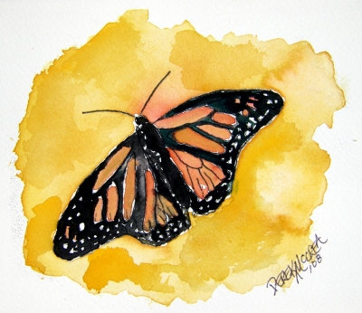

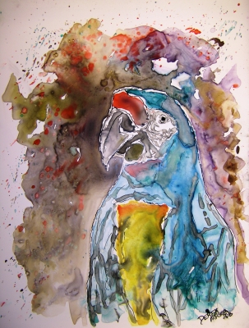

I have been busy painting and will keep it up take a look at my gallery if you get the time at

http://www.derekmccrea.50megs.com/

I am trying to complete a painting a day and have for the last several weeks. To get a daily update on completed works visit my blog below, enter your email address in the block provided under "subscribe to my art newsletter" It is a daily event unlike this newsletter which is a monthly sumary.

http://watercolorpaintingart.blogspot.com/

